Responsibility Breakdown
Frontend Design: Jovanny
Backend Design: Marcos and Gilberto
Database Design: Momen

Wireframes:
Jovanny
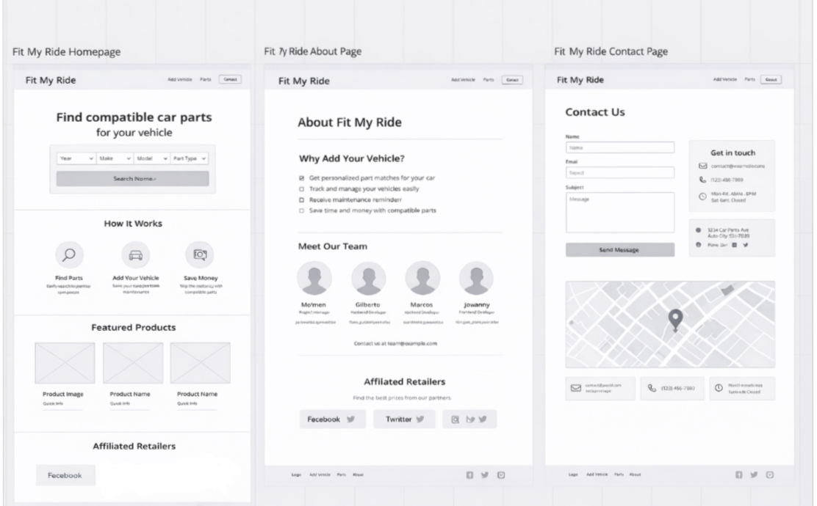
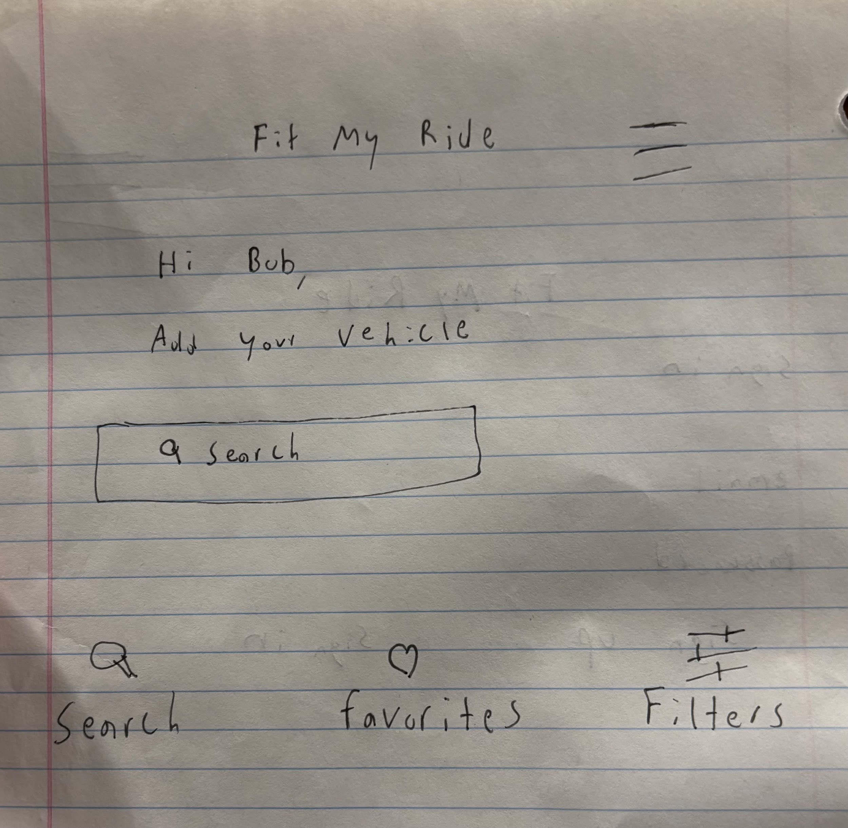
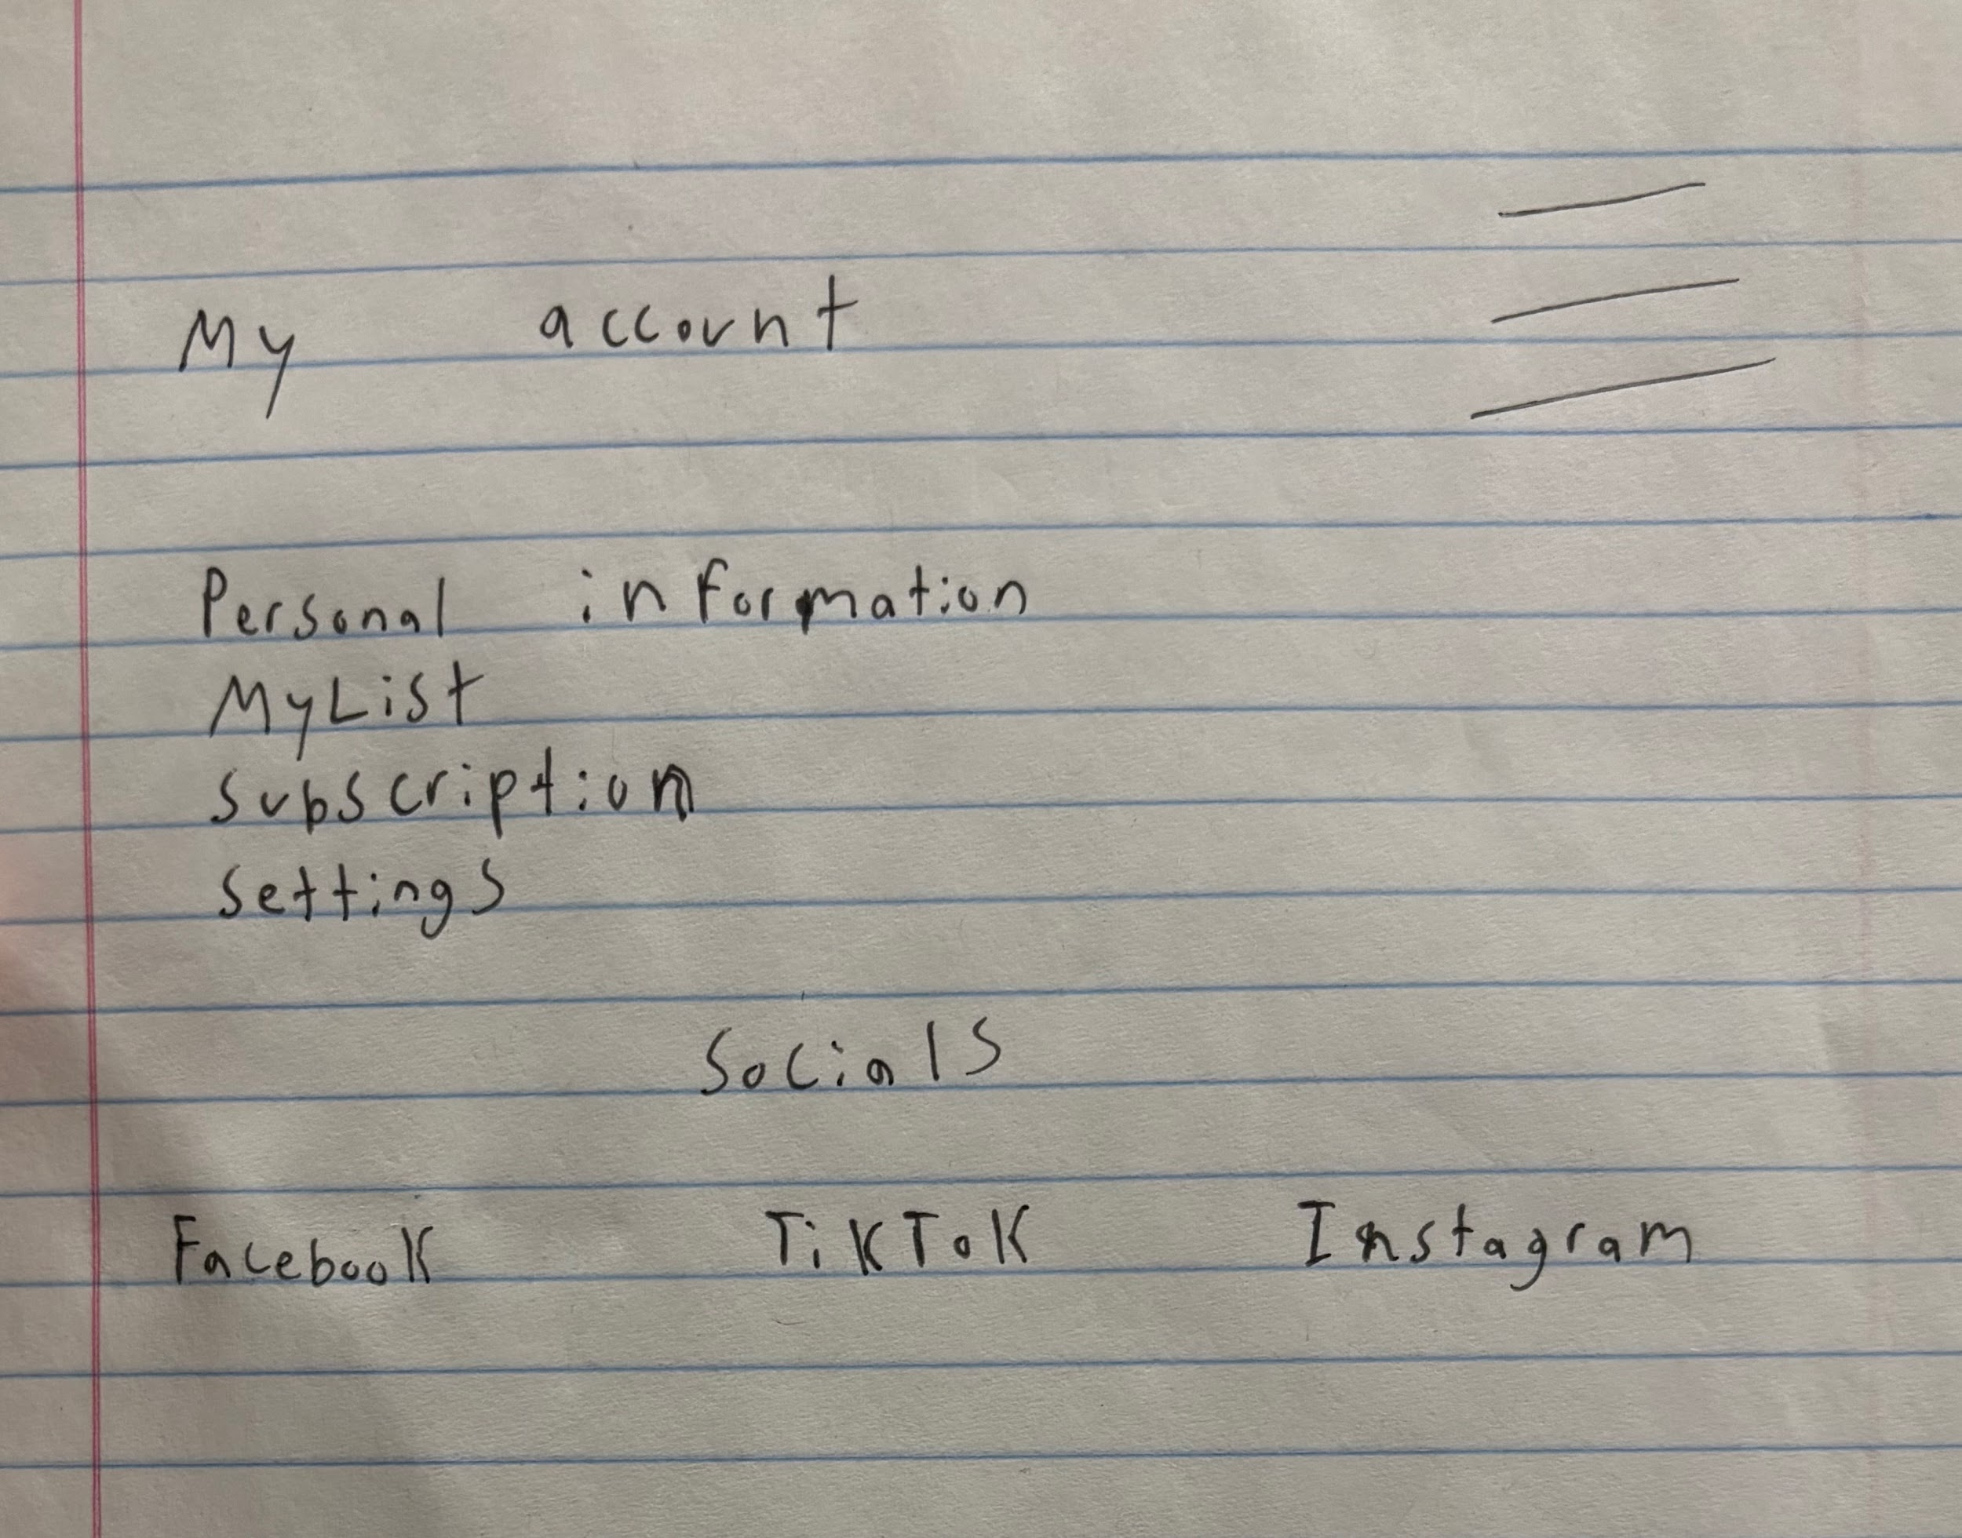
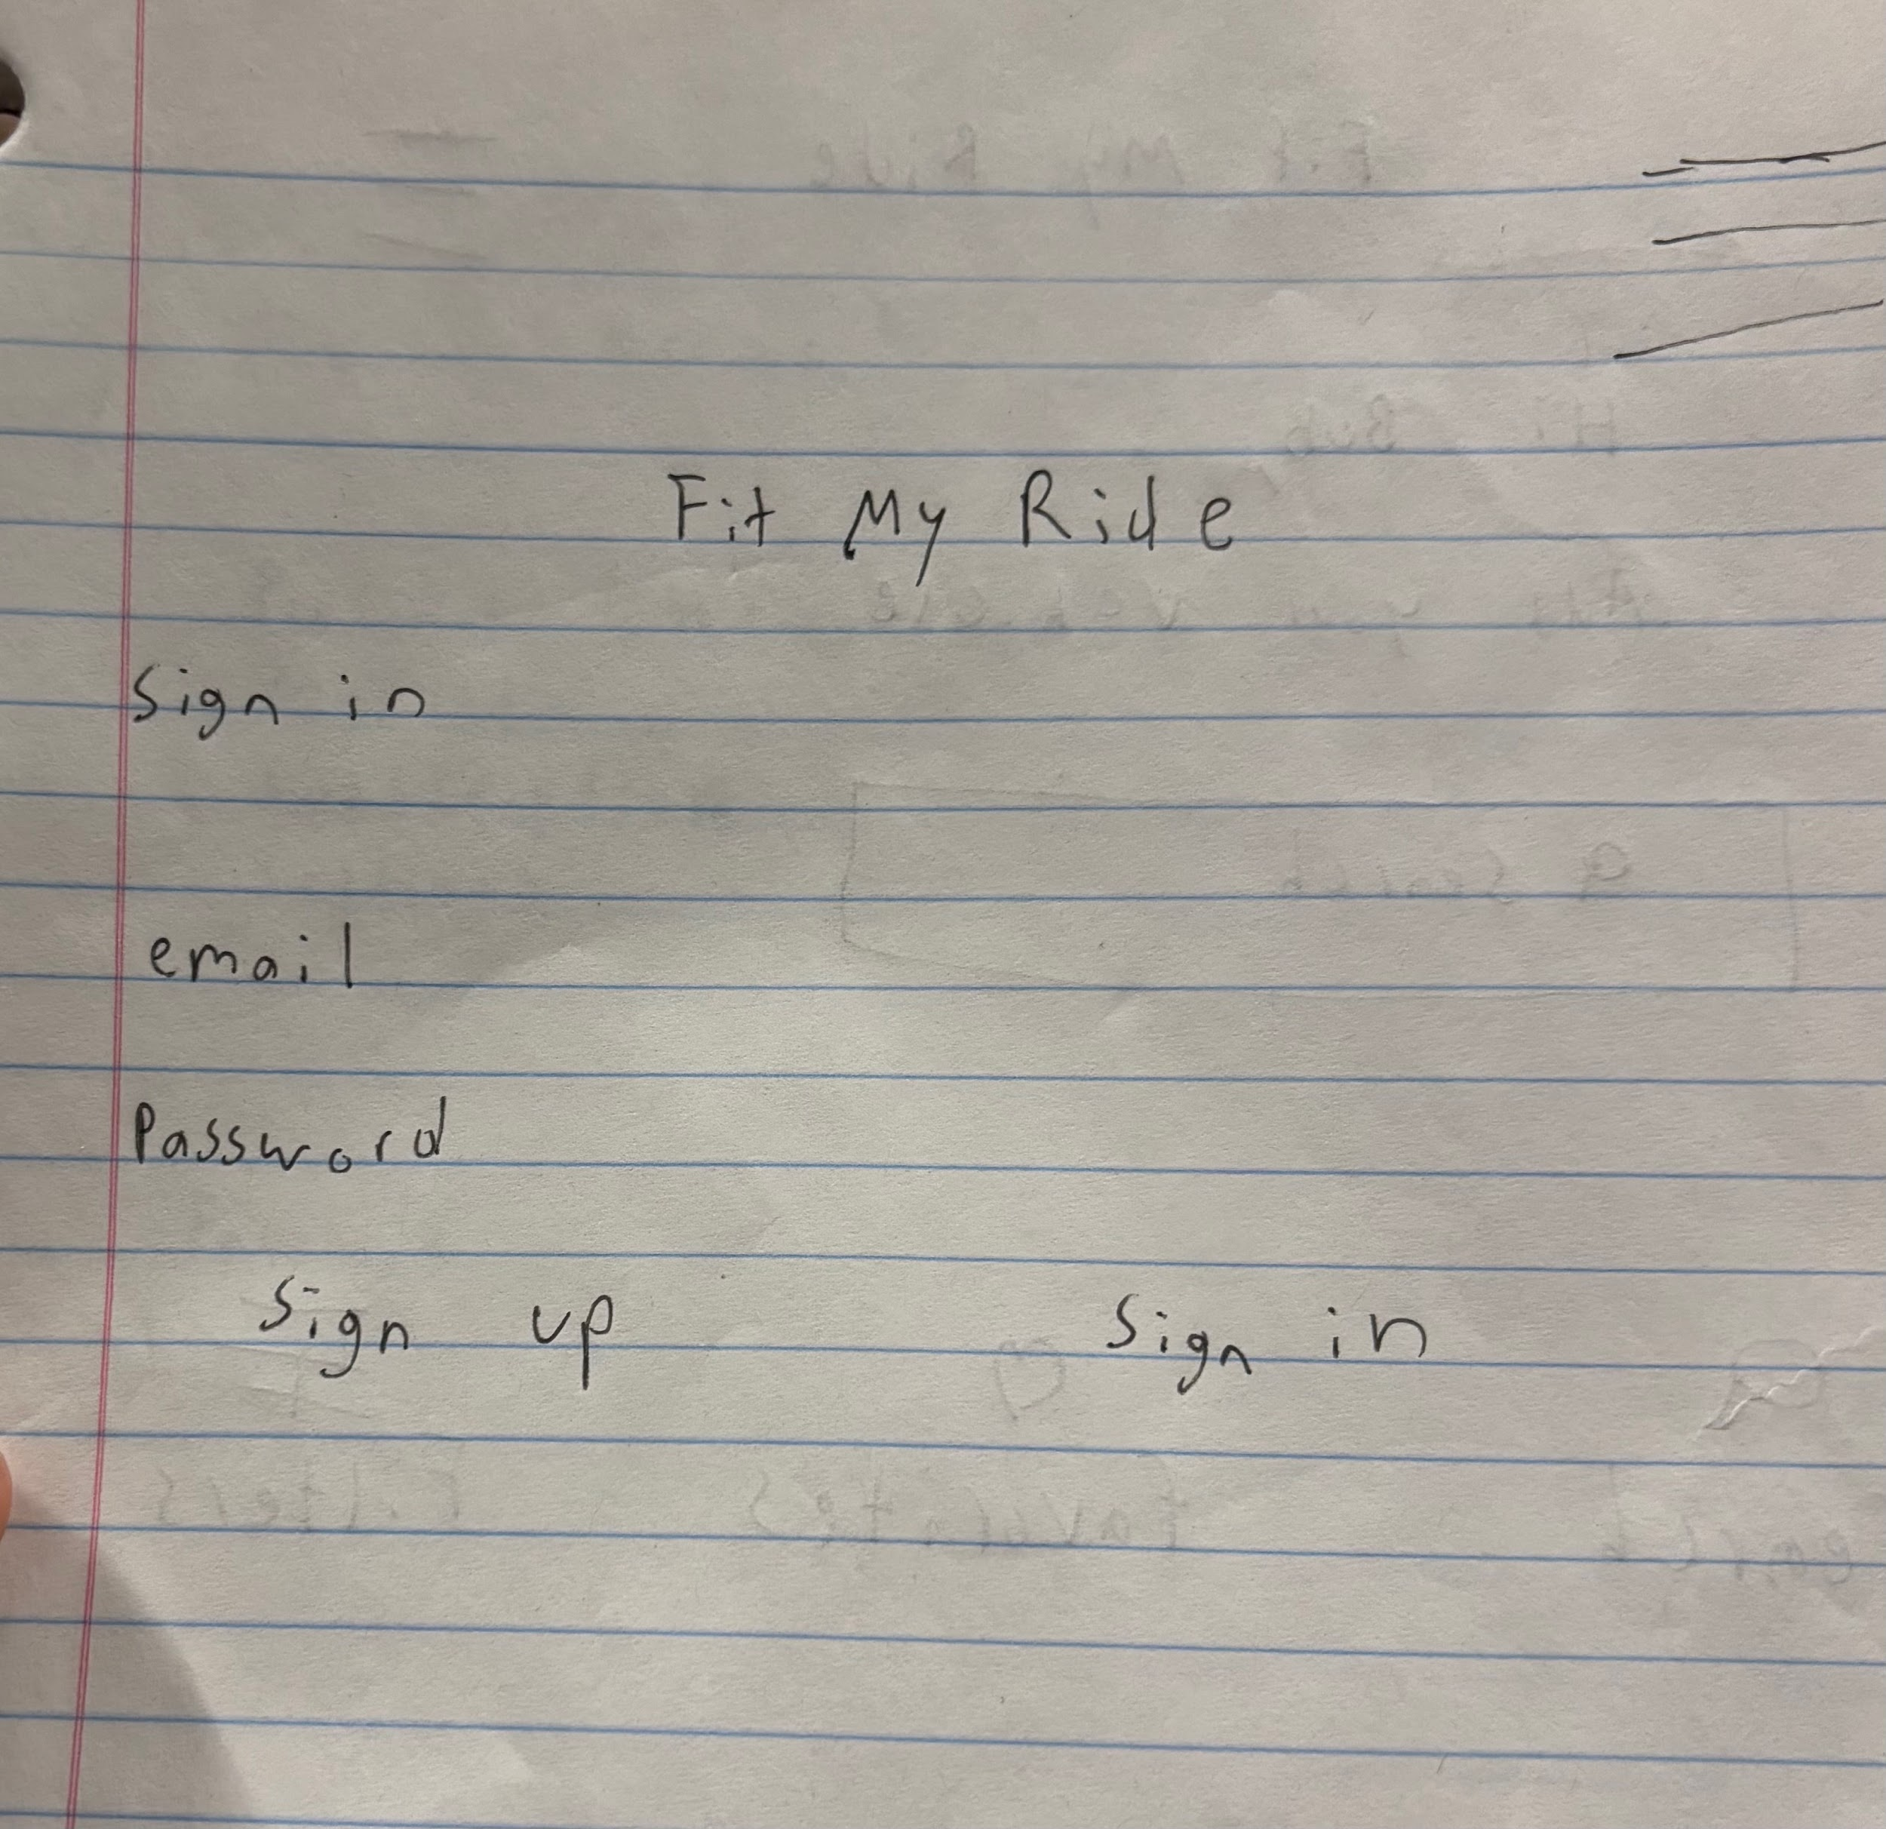

Pseudocode:

CONTINUE AS GUEST PSEUDOCODE (
IF user clicks "Continue as Guest"
SET userType = "Guest"
ALLOW searching for parts
ALLOW viewing compatible parts
END IF
IF guest tries to save data
DISPLAY "Please log in or create an account"
END IF
)

SAVE VEHICLE TOO PROFILE (
IF user is signed in
IF user enters vehicle information
SAVE vehicle to user account
DISPLAY "Vehicle saved"
END IF
ELSE
DISPLAY "Log in required to save vehicle"
END IF
)

Find compatible parts (
IF user selects a vehicle THEN
retrieve vehicle year
retrieve vehicle make
retrieve vehicle model
search parts database using vehicle
year, make, and model

IF matching parts are found THEN
display list of compatible parts to user
ELSE
display "No compatible parts
available"
END IF
)

Database Design:
Three core features: Vehicle and part compatibility, which will show any available parts that fit your ride

Users accounts and vehicle management, which allows you to add and save data to your account.

Maintenance reminders, allows you to set reminders for your vehicle maintenance.

Hosting Notes: The application will be hosted using cloud-based services. The frontend will be deployed using a static web hosting platform, while the backend and MySQL database will be hosted on a cloud provider that supports web applications. Local hosting will be used during development, and cloud hosting will be used for final deployment and presentation. We have yet to be accepted so all options are still open.

